ACADEMIC PROJECT REPORT
AI Loan Eligibility Checker
& Financial Mentorship System
Deterministic BFSI Decisioning • Credit Bureau Health Analytics • GenAI Coaching

Project Domain | FinTech / Banking, Financial Services & Insurance (BFSI) and Applied AI
Academic Purpose | Capstone / Final Year Engineering Demonstration
Core Technology | Node.js, Express.js, Vanilla HTML5 / CSS3 / ES6+, Anthropic Claude 3.5 Sonnet
Persistence Layer | Google Sheets API Webhook (Google Apps Script) + In-Memory Session Cache
Validation Status | 100% automated test suite passing (52 of 52 unit and integration tests)

SUBMISSION DETAILS
Submitted by | Avinash Chavan
Roll No. | 22107
Programme & Branch | SY. B.Tech Artificial Intelligence & Data Science
Institution | Dr. D.Y Patil College of Engineering and Innovation
Academic Year | 2026-27

Table of Contents
1. Executive Summary & Abstract 3
1.1 Project at a Glance 3
1.2 Key Contributions 4
2. Problem Statement & Motivation 4
2.1 Challenges Identified 4
2.2 Project Objectives 4
2.3 Scope and Target Users 5
3. Core Architectural Principles 5
3.1 The Four Principles 5
3.2 System Architecture 6
3.3 Separation of Responsibilities 6
3.4 Typical Request Lifecycle 6
4. Complete Technology Stack & Tools Used 7
4.1 Rationale for Key Technology Choices 8
5. Mathematical Formulations & Underwriting Algorithms 8
5.1 Reducing-Balance Equated Monthly Installment (EMI) 8
5.2 Month-by-Month Amortization Schedule Algorithm 9
5.3 Fixed Obligation to Income Ratio (FOIR) 9
5.4 Debt-to-Income (DTI) Ratio 10
5.5 Maximum Approved Borrowing Capacity (Present Value Annuity) 10
5.6 Applicant Age & Retirement Gating 11
5.7 Composite Eligibility Score (0–100 Points) 11
5.8 Decision Rules & Worked Scenarios 12
6. Modular Feature Breakdown 12
6.1 Module 1 — Loan Checker 13
6.2 Module 2 — Credit Analyzer 13
6.3 Module 3 — EMI Simulator 13
6.4 Module 4 — AI Financial Mentor 13
6.5 Module 5 — Google Sheets Logging 14
7. Generative AI Mentorship & Guardrails Design 14
7.1 Guardrail Design 14
7.2 Structured Response Contract 14
7.3 Fallback Behaviour 15
8. Google Sheets Cloud Integration Architecture 15
8.1 Submission Flow 15
8.2 Design Trade-offs 15
9. Project Directory & File Structure Walkthrough 16
10. REST API Specification & Data Contracts 17
10.1 Example Request 17
10.2 Health Endpoint 18
11. Security, Privacy & Defensive Engineering 18
11.1 Privacy Considerations 19
12. Verification & Automated Test Suite 19
12.1 Testing Strategy 19
13. Setup, Installation & Execution Guide 20
13.1 Prerequisites 20
13.2 Step-by-Step Instructions 20
13.3 Troubleshooting 21
14. Academic Viva Voce & Interview Preparation Q&A 21
15. Conclusion & Future Roadmap 23
15.1 Learning Outcomes 23
15.2 Limitations 23
15.3 Future Roadmap 23
Appendix A — Glossary of Terms 24
Appendix B — References 24

1. Executive Summary & Abstract
Modern digital lending platforms demand rapid, reliable, and legally compliant underwriting decisions. However, integrating Artificial Intelligence directly into the mathematics of a loan decision introduces significant risks, including stochastic hallucination, regulatory non-compliance, and approvals or denials that nobody can explain or audit.
The AI Loan Eligibility Checker & Financial Mentorship System demonstrates an industry-grade hybrid architecture that resolves this conflict. All quantitative financial calculations — Fixed Obligation to Income Ratio (FOIR), Debt-to-Income (DTI), reducing-balance Equated Monthly Installments (EMI), month-by-month amortization schedules, maximum borrowing limits via the Present Value Annuity formula, and 5-factor credit tier mapping — are computed 100% deterministically by a secure Node.js backend.
Generative Artificial Intelligence (Anthropic Claude 3.5 Sonnet) is used strictly as an educational, qualitative financial mentor. It explains the decision, illustrates the impact on disposable income, and provides a four-pillar credit improvement roadmap — but it is never allowed to calculate, alter, or approve a figure.
ACADEMIC NOTICE
This project is developed strictly for academic demonstration and financial literacy education. It simulates retail-banking credit underwriting heuristic models and does not represent an actual NBFC or financial advisory firm.

1.1 Project at a Glance
Table 1: Key project metrics
Metric | Value | Description
Functional modules | 5 | Loan Checker, Credit Analyzer, EMI Simulator, AI Financial Mentor, Google Sheets Logging
REST API endpoints | 7 | Five POST and two GET endpoints, all returning a consistent JSON contract
Automated tests | 52 / 52 | Native Node.js test runner; complete suite executes in under 2 seconds
Credit health factors | 5 | Payment history, utilization, credit history length, credit mix, new inquiries
AI mentoring pillars | 4 | Verdict rationale, cash-flow impact, credit repair, responsible borrowing
Rate limit | 150 req / 15 min | Per-IP throttling to mitigate abuse and denial-of-service attempts
AI timeout threshold | 10 seconds | After which the system switches to the offline heuristic fallback engine
External UI libraries | 0 | Entire front end is built with vanilla HTML5, CSS3 and ES6+

1.2 Key Contributions
- A strict separation of concerns between a deterministic financial engine and a generative AI layer, with the AI receiving calculated results only as read-only facts.
- A complete underwriting pipeline covering income-tiered FOIR limits, DTI, age and retirement gating, credit-tier-adjusted borrowing capacity and a 0–100 composite eligibility score.
- A zero-crash resilience model: the platform keeps working when the Claude API key is missing, the network times out, or rate limits are hit, and when Google Sheets is unavailable.
- A privacy-first engineering approach with server-side secrets, regex-based redaction of API keys and e-mail addresses from logs, and strict input validation.
- A verified implementation backed by 52 automated unit and integration tests with a 100% pass rate.

2. Problem Statement & Motivation
In the retail lending landscape, borrowers frequently face loan rejection because of a lack of financial literacy rather than a lack of repayment ability. The challenges identified during the study of existing tools and banking practice are summarised below.

2.1 Challenges Identified
- Lack of Pre-Application Self-Assessment: Borrowers often apply for credit without understanding how banks calculate debt burden (FOIR) or how existing EMIs reduce their borrowing capacity. Every unsuccessful application can also leave a hard inquiry on the credit report.
- Opaque Rejection Rationales: Traditional credit rejection letters state generic reasons (for example, “Internal Policy Criteria”) without explaining the root cause or giving actionable remediation steps.
- Risks of Pure AI Lending: Attempting to replace underwriting rules with a raw Large Language Model leads to calculation discrepancies, numerical hallucination, and a complete lack of auditability.
- Disjointed Tools: Most online tools offer a standalone EMI calculator without checking whether the applicant’s income and debt profile can safely service the monthly installment.

2.2 Project Objectives
Table 2: Objectives and how each is addressed
ID | Objective | Addressed by
O1 | Give borrowers an instant, transparent pre-application eligibility verdict | Module 1 — Loan Checker
O2 | Make credit bureau score components understandable and actionable | Module 2 — Credit Analyzer
O3 | Let users explore how amount, rate and tenure change repayment | Module 3 — EMI Simulator
O4 | Explain the decision in plain language and suggest improvements | Module 4 — AI Financial Mentor
O5 | Maintain an auditable record of assessments without a heavy database | Module 5 — Google Sheets Logging
O6 | Guarantee that no AI output can alter a financial figure | Deterministic / generative separation
O7 | Remain available and secure under failures and misuse | Fallback engines, validation, rate limiting, redaction

2.3 Scope and Target Users
In scope: retail loan pre-assessment for salaried and self-employed individuals, credit health education, EMI simulation, qualitative AI coaching and assessment logging. Out of scope: actual loan disbursement, KYC verification, live credit bureau pulls, document verification, and any binding credit decision.
The intended users are first-time borrowers, young professionals, students of finance and engineering evaluating the system academically, and educators demonstrating the safe use of generative AI in regulated domains.

3. Core Architectural Principles
The system is built upon four strict software-engineering and financial-engineering principles. Each principle is a deliberate response to a specific risk described in the problem statement.

3.1 The Four Principles
- Deterministic Calculation Separation. All core financial calculations are computed on the Node.js backend using standard banking formulas. The AI model is strictly quarantined from altering, calculating or approving loan figures. Because the same input always produces the same output, every decision is reproducible and auditable.
- AI as Qualitative Mentor. Anthropic Claude receives calculated financial facts (FOIR, DTI, score, status) as immutable read-only context and generates structured financial-literacy mentoring across four predefined pillars. The AI adds explanation, not authority.
- Fail-Safe Offline Resilience. The platform implements a zero-crash architecture. If the Claude API key is missing, the network times out (> 10 s), or rate limits are reached, the system transparently shifts to an internal heuristic rule engine without disrupting the user.
- Zero Secret Leakage & PII Redaction. All API credentials reside exclusively on the server. Outgoing logs and error messages undergo automated regex sanitization to redact API keys and e-mail addresses.

3.2 System Architecture
Figure 1 shows the layered architecture. Every request passes through the same security pipeline before reaching one of three services. Notice that the deterministic engine feeds facts to the AI mentor service, but there is no path by which the AI service can write back into the engine.
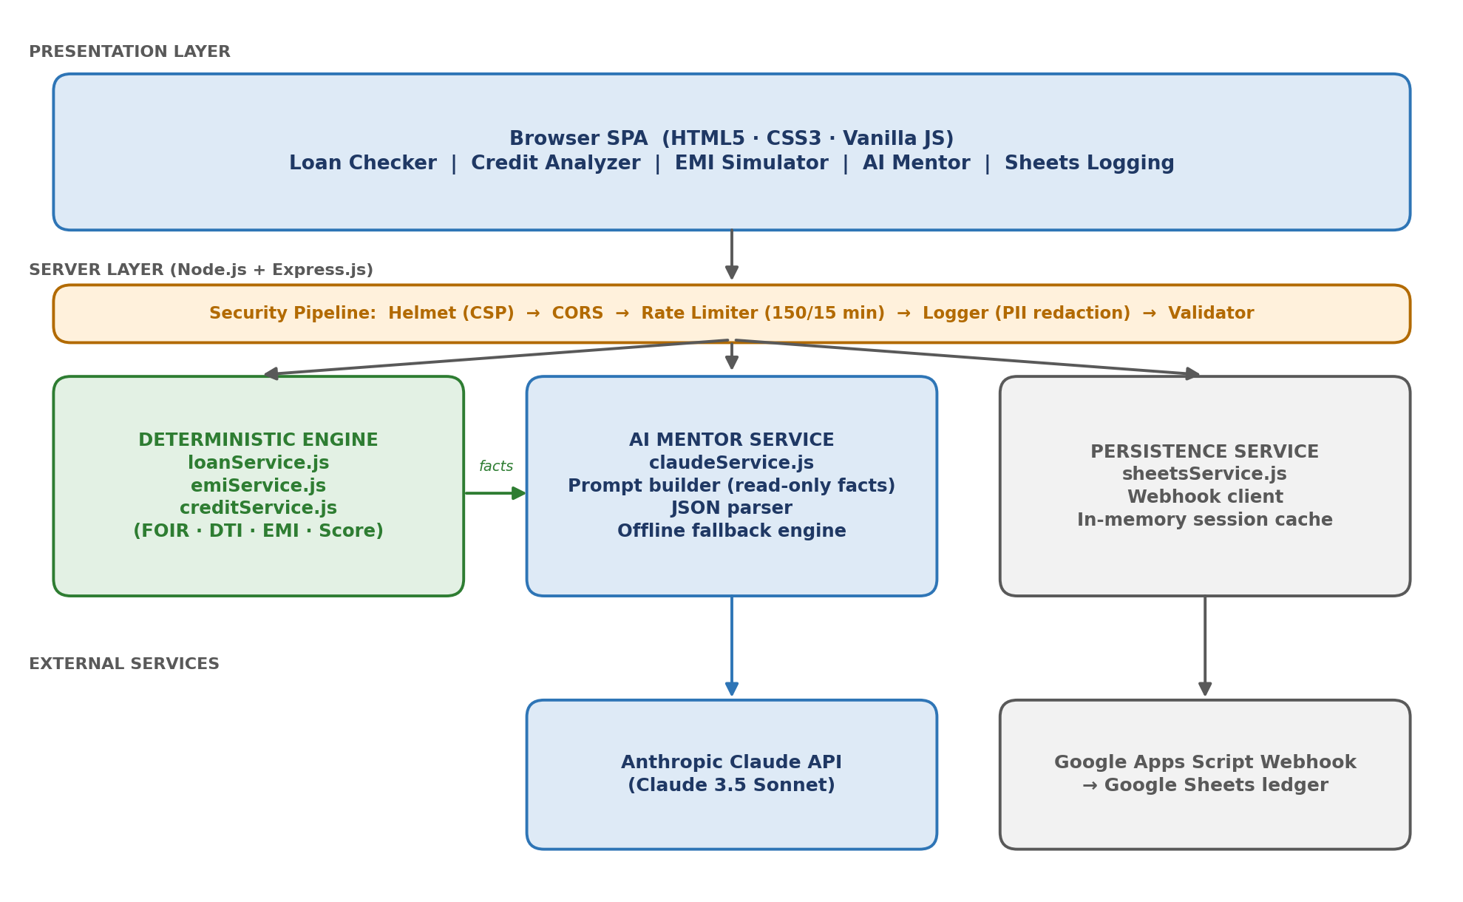
Figure 1: High-level system architecture — the deterministic engine is isolated from the generative AI layer

3.3 Separation of Responsibilities
Table 3: Responsibility split between the deterministic engine and the generative AI
Concern | Deterministic Engine (Node.js) | Generative AI (Claude)
EMI, FOIR, DTI, capacity | Calculates — sole authority | Never calculates; receives as read-only facts
Eligibility verdict | Decides (Eligible / Conditional / Ineligible) | Explains the verdict in plain language
Credit tier mapping | Maps score to tier and capacity factor | Suggests credit-repair behaviour
Output format | Strictly typed numbers and enums | Validated JSON text fields only
Auditability | Fully reproducible and unit-tested | Non-deterministic; advisory only
Failure behaviour | Input validation errors returned | Replaced by offline heuristic engine

3.4 Typical Request Lifecycle
- The user enters income, obligations, loan amount, tenure, interest rate, credit score, age and employment type in the browser.
- The front-end controller posts the data to /api/loan/check.
- The security pipeline applies Helmet headers, CORS policy, rate limiting, request logging with redaction and input validation.
- The loan service computes EMI, FOIR, DTI, maximum borrowing capacity, composite score and eligibility status.
- The verdict and metrics are rendered in the interface. The cached assessment is held for the AI mentor and the logging module.
- If the user requests coaching, /api/ai/tips sends the calculated facts to Claude (or the fallback engine) and renders the structured response.
- If the user submits the assessment, /api/assessment/submit sanitizes personal data and writes it to Google Sheets or the in-memory cache.

4. Complete Technology Stack & Tools Used
The software uses a modular, lightweight and modern stack built from scratch. The front end deliberately avoids frameworks to keep the client small, transparent and easy to audit, while the back end relies on a small set of well-maintained, security-conscious Node.js packages.
Table 4: Technology stack
Layer / Component | Technology | Version | Role in System Architecture
Frontend Markup | HTML5 | W3C Spec | Semantic structure, modular tabs, accessibility, SEO tags
Frontend Styling | CSS3 / Custom Props | Grid & Flex | Dark glassmorphism, responsive UI tokens, SVG gauges
Frontend Logic | Vanilla JavaScript | ES6+ | DOM coordination, fetch wrapper, zero external UI libraries
Backend Runtime | Node.js | >= 18.0.0 | Asynchronous event-driven execution environment
Web Framework | Express.js | v4.21.2 | REST API routing, middleware pipeline, static file serving
HTTP Security | Helmet | v8.0.0 | CSP headers, XSS prevention, HTTP header hardening
Rate Limiting | express-rate-limit | v7.5.0 | DDoS and API abuse mitigation (150 req / 15 min)
CORS Security | CORS | v2.8.5 | Cross-origin resource sharing configuration
Environment | dotenv | v16.4.7 | Secure configuration loader for environment secrets
AI Provider | Anthropic Claude API | v0.39.0 SDK | Claude 3.5 Sonnet qualitative coaching via structured prompts
Persistence | Google Apps Script | Webhooks (POST) | Serverless ledger logging assessments directly to Google Sheets
Automated Testing | Node.js Test Runner | node --test | Native unit and integration test runner (52 test cases)

4.1 Rationale for Key Technology Choices
- Node.js and Express.js: A single language (JavaScript) across client and server reduces context switching. Express provides a minimal, well-understood middleware pipeline ideal for layering security controls.
- Vanilla front end: Removing framework dependencies shrinks the attack surface, eliminates build tooling, and lets examiners trace every DOM update directly in the source.
- Native Node.js test runner: Using node --test avoids third-party test dependencies while still supporting unit, integration and mocking scenarios.
- Google Apps Script webhook: A serverless endpoint in front of a spreadsheet gives a free, human-readable ledger that a non-technical reviewer can open instantly, with no database installation.
- Anthropic Claude: Strong instruction-following and reliable structured JSON output make it suitable for a tightly constrained mentoring role.

5. Mathematical Formulations & Underwriting Algorithms
This section documents every formula implemented by the deterministic engine. Each formula is accompanied by a plain-language explanation and, where useful, a worked numerical example. The examples in this section are illustrative inputs chosen to demonstrate the logic; values were computed directly from the formulas shown.

5.1 Reducing-Balance Equated Monthly Installment (EMI)
In a reducing-balance loan, interest is calculated every month only on the remaining unpaid principal balance. Given Principal (P), Annual Interest Rate (R %) and Tenure (N months):
EMI FORMULA
Monthly interest rate: r = R / (12 × 100)

For r > 0: EMI = P × r × (1 + r)^N / [ (1 + r)^N − 1 ]
For r = 0: EMI = P / N (zero-interest handling)

Total Amount Payable = EMI × N
Total Interest Paid = Total Amount Payable − P

Worked Example — EMI
Principal P = ₹5,00,000, annual rate R = 10.5 %, tenure N = 60 months. Then r = 10.5 / 1200 = 0.00875.
EMI = ₹10,746.95 | Total payable = ₹6,44,817 | Total interest = ₹1,44,817 (about 29 % of the principal).

5.2 Month-by-Month Amortization Schedule Algorithm
For each period t from 1 to N, the schedule splits the fixed EMI into an interest portion and a principal portion:
AMORTIZATION RECURRENCE
Interest Portion (t) = Opening Balance (t) × r
Principal Repaid (t) = EMI − Interest Portion (t)
Closing Balance (t) = max( 0, Opening Balance (t) − Principal Repaid (t) )
Opening Balance (t+1) = Closing Balance (t)
The max(0, …) guard prevents a tiny negative balance in the final period caused by floating-point rounding. The unit tests verify that the closing balance reaches zero at the end of the tenure.
Table 5: First three months of the example schedule (₹)
Month | Opening Balance | Interest | Principal | Closing Balance
1 | 5,00,000.00 | 4,375.00 | 6,371.95 | 4,93,628.05
2 | 4,93,628.05 | 4,319.25 | 6,427.70 | 4,87,200.35
3 | 4,87,200.35 | 4,263.00 | 6,483.95 | 4,80,716.40
Notice that the interest component falls each month while the principal component rises, although the EMI stays constant at ₹10,746.95. Figure 2 visualises this behaviour across the whole tenure.
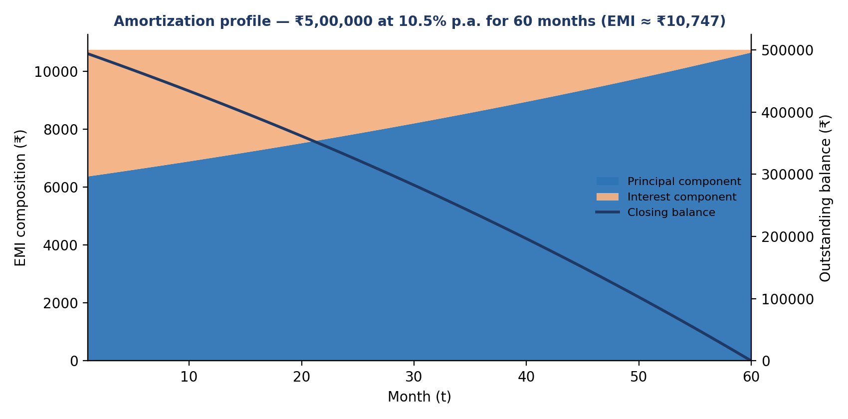
Figure 2: Amortization profile for ₹5,00,000 at 10.5% p.a. over 60 months

5.3 Fixed Obligation to Income Ratio (FOIR)
FOIR represents the total debt burden relative to net monthly cash inflow. It is the single most important affordability test used by Indian lenders.
FOIR
FOIR (%) = [ (Existing Monthly EMIs + Proposed Loan EMI) / Net Monthly Income ] × 100
The system enforces income-tiered benchmark limits. Higher earners retain more absolute disposable income after obligations, so lenders tolerate a higher percentage.
Table 6: Maximum permissible FOIR by income band
Net Monthly Income | Maximum FOIR | Band
≤ ₹30,000 | 40 % | Entry
₹30,001 – ₹75,000 | 50 % | Mid
> ₹75,000 | 60 % | High

5.4 Debt-to-Income (DTI) Ratio
DTI evaluates the pre-existing financial leverage of the applicant before considering the new loan. It complements FOIR by showing how stretched the applicant already is.
DTI
DTI (%) = [ Existing Monthly Debt EMIs / Net Monthly Income ] × 100
Table 7: FOIR versus DTI
Aspect | FOIR | DTI
Numerator | Existing EMIs plus proposed EMI | Existing EMIs only
Purpose | Tests affordability of the new loan | Shows current leverage
Used for | Eligibility decision and capacity | Risk context and AI coaching

5.5 Maximum Approved Borrowing Capacity (Present Value Annuity)
To prevent over-indebtedness, the system computes the maximum loan amount an applicant can qualify for. It first finds the largest EMI the applicant can afford, then converts that EMI into a principal using the present value of an annuity, and finally scales the result by the credit tier factor.
MAXIMUM BORROWING CAPACITY
1. Max Allowable EMI = (Monthly Income × Max FOIR Rate) − Existing EMIs

2. Max Borrowing Capacity = Max Allowable EMI × [ (1 − (1 + r)^(−N)) / r ] × Credit Tier Factor
The credit tier factors reflect how much of the theoretical capacity a lender is willing to extend at each level of bureau-assessed risk:
Table 8: Credit tier factors
Tier | Score Range | Factor | Effect on Capacity
Excellent | 750 – 900 | 1.00 | Full 100 % capacity
Good | 700 – 749 | 0.90 | 90 % capacity
Fair | 650 – 699 | 0.75 | 75 % capacity
Poor | 550 – 649 | 0.50 | 50 % capacity
Critical | 300 – 549 | 0.00 | Ineligible
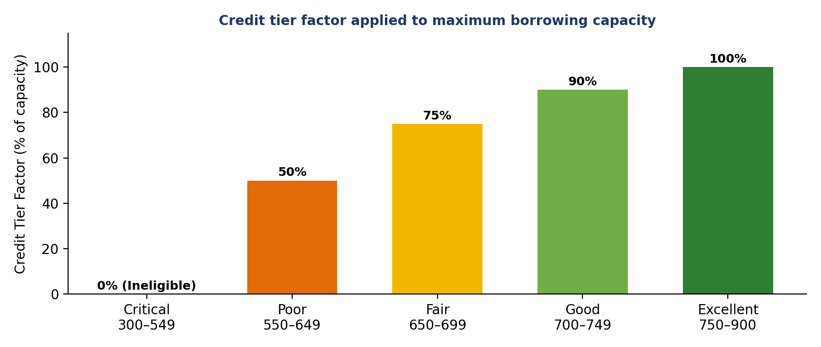
Figure 3: Credit tier factor applied to maximum borrowing capacity
Worked Example — Maximum Capacity
Monthly income ₹80,000 (high band, Max FOIR 60 %), existing EMIs ₹10,000, tenure 84 months at 8.5 %, credit score 740 (Good, factor 0.90).
Max Allowable EMI = 80,000 × 0.60 − 10,000 = ₹38,000. Annuity factor = (1 − (1 + 0.085/12)^−84) / (0.085/12) = 63.1453.
Capacity = 38,000 × 63.1453 × 0.90 ≈ ₹21,59,570.

5.6 Applicant Age & Retirement Gating
- Minimum Age: the primary applicant must be at least 21 years old. Applicants aged 18–20 are flagged Ineligible.
- Retirement Check: if [Applicant Age + (Tenure in Months / 12)] > 65 years, the status is set to Conditionally Eligible, because the repayment tenure extends past normal retirement age.
Worked Example — Retirement Gating
An applicant aged 55 requests a 180-month (15-year) loan. Age at maturity = 55 + 180/12 = 70 years, which exceeds 65, so the status becomes Conditionally Eligible. Reducing the tenure to 120 months gives 65 at maturity and removes the flag.

5.7 Composite Eligibility Score (0–100 Points)
The composite score provides an objective, explainable creditworthiness rating on a 0–100 scale. It is the weighted sum of four components:
Table 9: Composite score components
Component | Points | What it measures
FOIR Headroom Weight | 35 | How far the post-loan FOIR sits below the permitted limit
Credit Bureau Score Rating | 40 | Strength of the bureau score and its tier
Requested Principal vs. Max Capacity | 15 | How comfortably the request fits within computed capacity
Employment Stability Weight | 10 | Stability implied by the employment type
Total | 100

5.8 Decision Rules & Worked Scenarios
The following scenarios show how the rules combine. They mirror the categories exercised by the automated tests (prime approval, over-leveraged rejection, low credit score rejection, age check and retirement gating).
Table 10: Illustrative eligibility scenarios
Scenario | Inputs | Key computation | Verdict
A — Prime profile | Income ₹80,000; EMIs ₹10,000; loan ₹10,00,000 at 8.5 % for 84 m; score 740; age 32 | EMI ₹15,836.49  FOIR 32.30 % (limit 60 %)  DTI 12.5 %  Capacity ≈ ₹21.6 L | Eligible
B — Over-leveraged | Income ₹30,000; EMIs ₹12,000; loan ₹3,00,000 at 12 % for 36 m | EMI ₹9,964.29  FOIR 73.21 % (limit 40 %)  Max allowable EMI = ₹0 | Ineligible
C — Retirement | Age 55; tenure 180 months | 55 + 15 = 70 > 65 | Conditionally Eligible
D — Under-age | Age 19 | Age < 21 | Ineligible
E — Critical score | Credit score 520 | Tier Critical, factor 0.00 | Ineligible

6. Modular Feature Breakdown
The application is organised as five cooperating modules presented as accessible tabs within a single-page interface. The summary table gives an overview; the sub-sections describe each module in more detail.
Table 11: Module overview
Module | Primary Purpose | Core Inputs / Triggers | Outputs & Visual Features
Module 1: Loan Checker | Evaluates multi-factor retail loan eligibility | Income, existing EMI, requested loan, tenure, rate, credit score, age, employment | Eligibility verdict (Eligible, Conditionally Eligible, Ineligible), 0–100 score, FOIR / DTI badges, max loan limit
Module 2: Credit Analyzer | Visualizes bureau score tiers and health factors | Credit score (300 to 900) | Dynamic SVG needle gauge; 5-factor weighted breakdown (Payment 35 %, Utilization 30 %, History 15 %, Mix 10 %, Inquiries 10 %)
Module 3: EMI Simulator | Interactive reducing-balance installment calculation | Principal, annual interest rate, tenure (sliders / inputs) | Synchronized sliders, EMI and total-interest cards, principal vs. interest ratio bar, full monthly amortization table
Module 4: AI Financial Mentor | Qualitative mentoring grounded on assessment facts | One-click trigger reading cached assessment metrics | Structured glassmorphic report with 4 pillars: Verdict Rationale, Cash Flow Impact, Credit Repair, Responsible Borrowing
Module 5: Google Sheets Logging | Assessment ledger submission and session history | Student name, e-mail, assessment payload | Serverless Apps Script webhook integration, success toasts, persistent browser session-history table

6.1 Module 1 — Loan Checker
The Loan Checker is the core of the system. It validates the eight inputs, calls the loan service and presents a verdict together with the supporting metrics. The result panel shows the verdict badge, composite score, FOIR and DTI badges, calculated EMI, and the maximum loan the applicant could qualify for, so a rejected user can immediately see what amount would have been acceptable.

6.2 Module 2 — Credit Analyzer
The Credit Analyzer translates a bureau score on the 300–900 scale into a tier, a description and a dynamic SVG needle gauge. It then explains the five weighted health factors so that the user understands which behaviours move the score the most.
Table 12: Credit health factors and improvement guidance
Factor | Weight | General improvement guidance
Payment History | 35 % | Pay every EMI and card bill on or before the due date; automate payments.
Credit Utilization | 30 % | Keep revolving credit usage well below the available limit.
Credit History Length | 15 % | Keep older accounts open and in good standing.
Credit Mix | 10 % | Maintain a healthy balance of secured and unsecured credit.
New Inquiries | 10 % | Avoid multiple loan applications within a short period.

6.3 Module 3 — EMI Simulator
The EMI Simulator lets the user move sliders for principal, interest rate and tenure; values are kept synchronized with numeric inputs. Summary cards show the EMI, total payable and total interest; a ratio bar shows the principal-to-interest split; and the full month-by-month amortization table can be inspected. It is useful for demonstrating how a longer tenure reduces the EMI but increases total interest.

6.4 Module 4 — AI Financial Mentor
With one click, the mentor reads the cached assessment and requests coaching from the AI service. The result is presented in four pillars — Verdict Rationale, Cash Flow Impact, Credit Repair and Responsible Borrowing — and a badge states whether the text came from Claude or from the offline fallback engine, so the user is never misled about its source.

6.5 Module 5 — Google Sheets Logging
Users may submit their name, e-mail and assessment to a Google Sheets ledger through a serverless Apps Script webhook. A success toast confirms the submission, and a session-history table in the browser lists previous assessments. If the webhook is not configured or is unreachable, the assessment is kept in an in-memory session cache and no error is shown to the user.

7. Generative AI Mentorship & Guardrails Design
To satisfy academic and regulatory expectations, Anthropic Claude 3.5 Sonnet operates within rigid prompt-engineering guardrails. The design assumes that the model is helpful but fallible, and therefore constrains both its inputs and its outputs.

7.1 Guardrail Design
Table 13: AI guardrails and the risk each one mitigates
# | Guardrail | How it works | Risk mitigated
1 | Immutable Fact Injection | The backend executes all math first and injects metrics (FOIR, DTI, Max Loan, Status) into the prompt as read-only facts. | Numerical hallucination
2 | Prohibition of Numerical Changes | Claude is explicitly instructed that it has zero authority to alter, re-calculate or override financial figures. | Altered decisions
3 | JSON Schema Enforcement | The model must return valid JSON containing summary, strengths, riskFactors and recommendations arrays. | Unparseable output
4 | Offline Heuristic Fallback | If the API fails, times out (> 10 s) or is unconfigured, the server outputs identical JSON structures using deterministic logic, with a transparent UI badge. | Outages, rate limits

7.2 Structured Response Contract
Both Claude and the fallback engine return the same structure, so the front end needs no special-case logic. The source field tells the interface which engine produced the text.
{
"success": true,
"source": "claude" | "fallback",
"coaching": {
"summary": "...",
"strengths": ["..."],
"riskFactors": ["..."],
"recommendations": ["..."]
}
}

7.3 Fallback Behaviour
- Missing API key: the service is detected as unconfigured and the fallback engine is used immediately.
- Timeout (> 10 s): the request is abandoned and the fallback engine responds.
- HTTP 429 (rate limit) or network error: the error is caught, sanitized, and the fallback engine responds.
- Malformed model output: parsing failures are handled gracefully, ensuring the user always receives a valid structured response.
Design Takeaway
Because the numbers are computed first and passed to the model as fixed context, the worst realistic failure of the AI layer is unhelpful wording — never a wrong loan decision.

8. Google Sheets Cloud Integration Architecture
Instead of installing a heavy enterprise database such as PostgreSQL or Oracle, the system uses a lightweight Google Apps Script webhook in front of a Google Sheet. This keeps the project easy to deploy for an academic demonstration while still producing a durable, human-readable audit ledger.

8.1 Submission Flow
Table 14: Assessment submission sequence
Step | Actor | Action
1 | Client browser | Submits the assessment to POST /api/assessment/submit.
2 | Express server | Sanitizes the applicant name and e-mail, then dispatches an HTTPS POST request to the Google Apps Script webhook.
3 | Apps Script | Executes doPost(e), appends the row to the sheet, and responds with HTTP 200 JSON.
4 | Express server | If the webhook is unconfigured or offline, saves the assessment to the in-memory session history without throwing errors.

8.2 Design Trade-offs
Table 15: Google Sheets versus a conventional relational database
Aspect | Google Sheets webhook (chosen) | Relational database
Setup effort | Minutes; no installation | Install, configure, secure, migrate
Cost | Free | Hosting and maintenance cost
Auditability | Instantly readable by any reviewer | Requires queries or admin tooling
Scalability | Suitable for demonstration volumes | Suitable for production volumes
Resilience in project | In-memory cache fallback | Needs separate failure strategy
For production use the persistence layer could be replaced by a managed database behind the same sheetsService.js interface without changing any other module.

9. Project Directory & File Structure Walkthrough
The codebase follows a clear layered structure: routes receive requests, services contain business logic, middleware enforces cross-cutting concerns, and the public folder holds the browser application. Tests mirror the service layout.
Table 16: Key files across client, server and test suites
File Path | Layer | Function & Key Responsibility
server/index.js | Backend Core | Server entrypoint, Helmet / CORS middleware, static file routing, Port 3000 listen
server/routes/apiRoutes.js | API Routing | Consolidated REST endpoints (/api/loan/check, /api/emi/calculate, etc.)
server/services/loanService.js | BFSI Engine | FOIR, DTI, age gating, PV capacity math, and 0–100 composite scoring
server/services/emiService.js | BFSI Engine | Standard reducing-balance EMI math, 0 % APR handler, amortization loop
server/services/creditService.js | BFSI Engine | 5-factor credit tier weighting and bureau risk mapping
server/services/claudeService.js | AI Service | Anthropic Claude SDK client, prompt builder, and offline fallback engine
server/services/sheetsService.js | Persistence | Apps Script webhook client and session history manager
server/middleware/validator.js | Security | Defensive boundary validation for inputs (ranges, types, NaN checks)
server/middleware/logger.js | Security | Structured HTTP logging with automatic regex PII and secret redaction
public/index.html | Frontend UI | Single-page application layout with accessible tabs and metric cards
public/css/style.css | Design | Dark glassmorphic styling, responsive flex / grid, buttons, and animations
public/js/app.js | Frontend Logic | Master client coordinator managing tab switching, toasts, and mobile view
public/js/loanChecker.js | Frontend Logic | DOM controller for loan form submission and results rendering
public/js/emiCalculator.js | Frontend Logic | Slider synchronization and dynamic amortization table generation
tests/loanService.test.js | Testing | Unit tests for prime approvals, over-leverage rejections, and age gating
tests/emiService.test.js | Testing | Mathematical precision tests for EMI and period-by-period amortization

10. REST API Specification & Data Contracts
All endpoints accept and return JSON. Every response carries a boolean success field, which lets the front end handle outcomes uniformly. Inputs are validated by middleware before any business logic runs; invalid or out-of-range values are rejected with a descriptive error rather than being processed.
Table 17: REST endpoints
HTTP Method & Path | Request Body Payload | Success Response (200 OK)
POST  /api/loan/check | monthlyIncome, existingEmi, loanAmount, tenureMonths, interestRate, creditScore, age, employmentType | { success: true, isEligible, status, maxLoanAmount, foir, dti, eligibilityScore, reasons, calculatedEmi }
POST  /api/emi/calculate | principal, annualRate, tenureMonths | { success: true, emi, totalPayment, totalInterest, principal, schedule: [ { period, emi, principal, interest, balance } ] }
POST  /api/credit/analyze | creditScore (300 to 900) | { success: true, score, tier, description, factors: [ { factor, weight, impact, tip } ] }
POST  /api/ai/tips | monthlyIncome, requestedLoan, calculatedEmi, foir, dti, creditScore, status, maxLoanAmount | { success: true, source: 'claude' | 'fallback', coaching: { summary, strengths, riskFactors, recommendations } }
POST  /api/assessment/submit | applicantName, applicantEmail, assessmentData: { ... } | { success: true, stored: true | false, message }
GET  /api/assessment/history | None | { success: true, count, history: [ ... ] }
GET  /api/health | None | { status: 'healthy', timestamp, uptime, services: { claudeConfigured, sheetsConfigured } }

10.1 Example Request
The following request evaluates Scenario A from Section 5.8 (illustrative values):
POST /api/loan/check
Content-Type: application/json

{
"monthlyIncome": 80000,
"existingEmi": 10000,
"loanAmount": 1000000,
"tenureMonths": 84,
"interestRate": 8.5,
"creditScore": 740,
"age": 32,
"employmentType": "salaried"
}
The expected outcome is an Eligible verdict with a calculated EMI of about ₹15,836, FOIR of about 32.3 % and a maximum loan amount of about ₹21.6 lakh.

10.2 Health Endpoint
GET /api/health is designed for monitoring. Besides status, timestamp and uptime, it reports whether the Claude and Google Sheets integrations are configured, which makes it easy to confirm that the application is running in full mode or in offline fallback mode.

11. Security, Privacy & Defensive Engineering
Because the application handles financial and personal data, even in an academic setting, security is built into the pipeline rather than added afterwards. The table maps each threat to the control that addresses it.
Table 18: Threat model and implemented controls
Threat | Control | Implementation
Cross-site scripting, clickjacking, header-based attacks | Content Security Policy and header hardening | Helmet applies strict script-src and style-src directives
Abuse / denial of service | Rate limiting | express-rate-limit enforces 150 requests per 15-minute window per IP
Malformed or malicious input | Input validation | Custom validator middleware rejects NaN, string injection and out-of-range values
Credential and PII leakage | Secret masking | Logging and error handlers regex-mask API keys (sk-ant-*) and e-mail addresses
Service disruption by third parties | Graceful degradation | Server never crashes due to external API rejections, timeouts or unset variables
Exposure of API keys to browsers | Server-side secrets | Keys live only in environment variables loaded by dotenv

11.1 Privacy Considerations
- Applicant name and e-mail are sanitized before leaving the server.
- Logs are redacted automatically, so e-mail addresses and secrets do not appear in console output or error traces.
- The in-memory cache exists only for the lifetime of the server process and is not written to disk.
- No real credit bureau data or government identifiers are collected, in keeping with the academic nature of the project.

12. Verification & Automated Test Suite
The project includes 52 automated tests executed through the native Node.js test runner using node --test tests/**/*.test.js. All 52 tests complete in under two seconds with a 100 % pass rate. External services are mocked, so the suite is deterministic and runs without any network access or API keys.
Table 19: Test suite coverage
Test Suite / Domain | Count | Scenarios Tested
Loan Underwriting Tests | 9 | Prime approval, over-leveraged rejection, low credit score rejection, age < 21 check, retirement gating
EMI Engine Precision Tests | 6 | Benchmark loan calculation, 0 % APR handling, 1-month and 360-month tenures, amortization balance integrity
Credit Score Health Tests | 4 | Score tiers (300 to 900), boundary conditions, factor weighting verification
Claude AI Service Tests | 8 | Prompt guardrails, missing key fallback, mock parsing, 10 s timeout, HTTP 429 rate-limit fallback
Google Sheets Service Tests | 7 | Payload formatting, unconfigured fallback, timeout resilience, session cache persistence
Validation Middleware Tests | 5 | Missing field detection, boundary checking (negative income, invalid credit score)
Infrastructure & Security Tests | 11 | Logger PII redaction, AppError custom class, CORS headers, health check endpoint, 404 / 500 handlers
Financial Constants Integrity | 2 | Invariable constants freeze and benchmark limit verification
Total | 52 | 100 % passing

12.1 Testing Strategy
- Boundary-value analysis: scores at tier edges (for example 549 / 550 and 749 / 750), 1-month and 360-month tenures, and the 21-year age threshold.
- Invariant checks: the amortization closing balance must reach zero, and the sum of principal repaid must equal the loan amount.
- Failure injection: timeouts, HTTP 429 responses and missing keys are simulated to prove that fallbacks activate.
- Security regression: tests assert that e-mails and API-key patterns are redacted from log output.
- Constant immutability: financial benchmark tables are frozen so that no runtime code can alter them.
To run the suite, execute npm test from the project root.

13. Setup, Installation & Execution Guide

13.1 Prerequisites
- Node.js version 18.0.0 or newer, together with npm.
- Any modern web browser (Chrome, Edge, Firefox or Safari).
- Optional: an Anthropic API key for live Claude coaching, and a deployed Google Apps Script webhook URL for cloud logging. The application runs fully without either, using its offline fallbacks.

13.2 Step-by-Step Instructions
Table 20: Installation and execution steps
Step | Action | Command / Note
1 | Clone the repository or open the project directory | Navigate to the project root in a terminal
2 | Install dependencies | npm install
3 | Set up environment configuration | Copy .env.example to .env. Keys for Claude and Google Sheets are optional.
4 | Start the application server | npm start (Windows: double-click Launch AI Loan Checker.bat)
5 | Run the automated test suite | npm test
6 | Access the web interface | Open http://localhost:3000 in any web browser

# 1-2. Install
npm install

# 3. Configure (optional keys)
cp .env.example .env

# 4. Start the server
npm start

# 5. Run the 52 tests
npm test

# 6. Open in browser
http://localhost:3000

13.3 Troubleshooting
Table 21: Common issues and resolutions
Symptom | Resolution
Server will not start or reports syntax errors | Check node --version; Node.js 18 or newer is required.
Port 3000 already in use | Stop the other process using the port, or change the configured port in .env.
AI report shows a “fallback” badge | Expected when no Claude key is set, the network is slow, or a rate limit is hit. Add a valid key to enable live coaching.
Assessments are not appearing in Google Sheets | Confirm the webhook URL in .env and that the Apps Script is deployed for access. Entries remain available in the session history.
Many requests return an error after heavy use | The rate limiter allows 150 requests per 15 minutes per IP; wait for the window to reset.

14. Academic Viva Voce & Interview Preparation Q&A
The following questions and model answers prepare the presenter for the oral examination. Answers are written in a form that can be spoken in under a minute.
Q1. Why did you not use Machine Learning or an LLM to decide the loan approval?
In retail banking, credit underwriting is strictly regulated (for example by fair-lending principles and RBI guidelines). Lending decisions must be 100 % deterministic, explainable and mathematically auditable. Machine Learning models and LLMs suffer from non-deterministic variance and hallucinations, creating severe compliance risks. In our architecture, Node.js computes the deterministic underwriting formulas, and the LLM acts solely as an educational mentor.
Q2. What is FOIR and why is it important in loan evaluation?
FOIR (Fixed Obligation to Income Ratio) measures the percentage of an applicant’s monthly income committed to servicing debt — existing EMIs plus the proposed new EMI. Banks cap FOIR (typically 40 % to 60 %) to ensure borrowers retain sufficient disposable income for household expenses and emergencies, preventing default.
Q3. How does your system calculate the Maximum Borrowing Capacity?
It calculates the Maximum Allowable EMI as the applicant’s income-tier FOIR limit minus existing debt obligations. It then applies the Present Value Annuity formula, PV = EMI × [ (1 − (1 + r)^−N) / r ], and multiplies by a Credit Tier Risk Factor (0.0 to 1.0) to determine the maximum safe borrowing ceiling.
Q4. How does reducing-balance EMI differ from flat-rate interest?
In flat-rate loans, interest is calculated on the entire principal throughout the tenure. In reducing-balance loans, interest is recalculated each month only on the remaining unpaid balance. Over time the interest component decreases and the principal component increases, resulting in significantly lower overall interest for the borrower.
Q5. How does your system maintain resilience if the Claude API or Google Sheets is offline?
The architecture implements defensive graceful degradation. For Claude, the server catches network errors, timeouts or missing keys and activates a deterministic rule-based mentoring engine. For Google Sheets, assessments are automatically preserved in an in-memory session cache so no user data is lost.
Q6. What is the difference between FOIR and DTI in your system?
DTI uses only existing EMIs and shows how leveraged the applicant already is. FOIR adds the proposed EMI and therefore tests whether the new loan is affordable. FOIR drives the eligibility decision and capacity; DTI provides risk context and feeds the AI coaching.
Q7. How do you prevent the AI from changing a financial figure or being manipulated?
The numbers are calculated first and injected as read-only facts, the prompt forbids recalculation, and the output is constrained to a JSON schema of text fields. The AI’s response is never used to compute or override the verdict, so even a poor or manipulated response cannot change the decision.
Q8. Why did you use Google Sheets instead of a database?
The project is an academic demonstration, so a serverless webhook gives a free, zero-installation and human-readable audit ledger. The persistence logic is isolated in one service, so it can be swapped for a managed database in production without touching other modules.
Q9. Why is the front end written in vanilla JavaScript?
It removes framework dependencies and build tooling, reduces the attack surface, keeps the client lightweight and makes every DOM operation easy to trace during evaluation.
Q10. What are the limitations of the system and how could they be addressed?
It uses user-entered data rather than verified documents or live bureau pulls, and its scoring weights are heuristic rather than learned from real portfolio data. These can be addressed through OCR-based document parsing, account-aggregator integration and calibration against historical repayment data under proper governance.

15. Conclusion & Future Roadmap
The AI Loan Eligibility Checker successfully bridges the gap between mathematically rigorous financial underwriting and engaging, user-friendly financial-literacy education. By enforcing a clear architectural separation between deterministic calculation engines and generative AI mentorship, the system delivers high accuracy, zero calculation hallucination and resilient offline operation.

15.1 Learning Outcomes
- Application of standard banking mathematics (EMI, amortization, FOIR, DTI, annuity present value) in working software.
- Safe integration of a Large Language Model into a regulated domain through guardrails, schema enforcement and fallbacks.
- Secure web-service design with layered middleware, validation, rate limiting and data redaction.
- Test-driven verification of financial logic and failure behaviour using a native test runner.

15.2 Limitations
- Inputs are self-declared; no document or identity verification is performed.
- Composite score weights and tier factors are illustrative heuristics, not calibrated against historical data.
- The in-memory session cache is lost on server restart and is not shared across instances.
- The system does not model product-specific rules such as secured-loan LTV limits or lender-specific policy overrides.

15.3 Future Roadmap
Table 22: Planned enhancements
Enhancement | Description
OCR Integration | Automated bank statement and salary slip parsing via computer vision.
Multilingual Mentorship | Claude-generated financial coaching in regional languages (Hindi, Marathi, Tamil, etc.).
Biometric / Multi-Factor Auth | Secure applicant authentication for multi-session loan tracking.
Open Banking API Integration | Live account-aggregator hooks for real-time transaction verification.
Managed database option | Optional relational persistence behind the existing service interface for production-scale deployments.
Model-risk governance | Calibrating score weights against historical data with documented validation and monitoring.

Appendix A — Glossary of Terms
Term | Definition
BFSI | Banking, Financial Services and Insurance sector.
EMI | Equated Monthly Installment — fixed monthly repayment covering principal and interest.
FOIR | Fixed Obligation to Income Ratio — share of income committed to debt service including the proposed loan.
DTI | Debt-to-Income ratio — existing debt payments divided by income.
Reducing-balance | Interest method in which interest is charged only on the outstanding principal.
Amortization | Gradual repayment of a loan through scheduled payments split into interest and principal.
Present Value Annuity | Formula converting a stream of equal payments into an equivalent lump-sum principal.
Credit Bureau Score | Three-digit score (300–900 in India) summarising credit behaviour.
Credit Utilization | Proportion of available revolving credit currently in use.
Hallucination | Confident but incorrect output generated by a language model.
Guardrail | Constraint on a model’s inputs or outputs that limits unsafe or unwanted behaviour.
PII | Personally Identifiable Information such as name and e-mail address.
CSP | Content Security Policy — browser mechanism restricting the sources of scripts and styles.
Webhook | HTTP endpoint that receives data pushed by another system.

Appendix B — References
- Reserve Bank of India — Fair Practices Code for Lenders and related circulars on credit and digital lending.
- TransUnion CIBIL — Credit score and credit report documentation (score range 300–900).
- Anthropic — Claude API documentation and Messages API reference, docs.anthropic.com.
- Node.js Foundation — Node.js documentation, including the built-in test runner (node:test), nodejs.org.
- Express.js — Express 4.x routing and middleware documentation, expressjs.com.
- Helmet.js — Documentation for HTTP security headers and Content Security Policy, helmetjs.github.io.
- OWASP Foundation — OWASP Top 10 and Secure Headers Project, owasp.org.
- Google — Apps Script Web Apps documentation, developers.google.com/apps-script.
- Brigham, E. F. and Houston, J. F. — Fundamentals of Financial Management (time value of money and annuities).

